The below code #11 is taking too long to execute

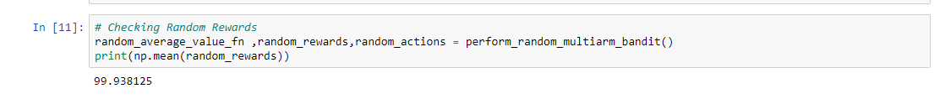

Following errors we get while executing further.

